T&C Service interface doc

Prepared by

Ford Motor Company

23-June-2022

Version 1.0

Contributor

Zhu Jialin

|  |  |  |  |
| --- | --- | --- | --- |
| REVISION HISTORY | | | |
| Version | Date | Name | Comment |
| 1.0 | 8-Sept-2021 | Zhang Jia | Initial version |
| 1.1 | 4-Mar-2022 | Zhang Jia | Add customer feedback upload voice text interface |
| 1.2 | 17-May-2022 | Zhang Jia | Add Lidget TNC |
| 1.3 | 19-Junly-2022 | Zhu Jialin | Add valid time interface Add param to withdrawTncAccept |

1. Introduction

This document describes the interfaces exposed by T&C Service which support T&C storage, user accept status record and status withdraw functions.

1. Interface Matrix

Below table summarize all APIs provided by IVI Service Layer

|  |  |  |
| --- | --- | --- |
| class | interface | description |
| **TncManager** | boolean init(Context context) | init to bind remote tnc service, this method is strongly recommended to be called in android application. |
|  | Void registerTncListenr(TncListener tncListener); | Register callback to listen if the latest T&C has changed. |
|  | Void unregisterTncListener(); | Clear listener |
|  | TncInfo getTncInfo(String feature); | Obtain T&C info, which contains message such as localPath, see TncInfo class below. |
|  | void setTncAccepted(String feature, String llid, String openId) | Set user accept status for defined feature with specified llid |
|  | Boolean isTncAccepted(String feature, String openId) | Return the user accept status for feature |
|  | Void uploadFeedbackContent(String voiceText, String feedbackId, final Callback<T> callback); | Upload user feedback content  This is specified method for CustomerFeedback feature. |
|  | void setTncValidTime(String featue, int days, String openId) | Set valid time length, count in days |
|  | boolean withdrawTncAccept(String feature,String llid, String openId); | Withdraw user accept status |
|  | int getTncValidTime(String feature, String openId) | Return remaining months for this user accept valid time |
| **Callback<T>** | void onSuccess(int code, T object); | Upload callback for success |
| void onFail(int code, String error); | Upload callback for fail |

|  |  |  |
| --- | --- | --- |
| **TncListener** | void onTncChanged(TncInfo tncInfo); | Callback for T&C changed, mostly this happens after communication with cloud. |

1. Interface description

com.ford.sync.tspservice.TncManager.java

currently supported feature list is as below:

public static final String *MULTI_MODE* = "MultiMode";  
public static final String *DMS* = "DMS";  
public static final String *FACEID* = "FaceID";  
public static final String *VOICE_FEEDBACK* = "VoiceFeedback2";  
public static final String *LIDGET* = "Lidget2";  
public static final String *V2I* = "V2I";  
public static final String *INTERNET_PP* = "Internet_Policy";  
public static final String *SYSTEM_PP* = "System_Policy";  
public static final String *PI_PP* = "PI_Policy";

* 1. public boolean init(Context context);

Init function for other feature to setup connection with T&C service, return true if no error occurs, if false, please retry in code after seconds or check whether T&C service boots up normally. We strongly recommend other feature integrate this method in Android application.

* 1. public void registerTncListener(TncListener tncListener);

Register a callback to listen whether the TncInfo has been updated in cloud. TncInfo update happens mostly in first IVI boots up everyday.

* 1. public void unregisterTncListener(TncListener tncListener);

unregister listener when unneeded.

* 1. public TncInfo getTncInfo(String feature);

Return a instance of TncInfo class, which contains the info like llid, feature name and local path, other feature uses mLocalPath to load a html page to show the T&C info, this is a local path which usually stored in SD card.

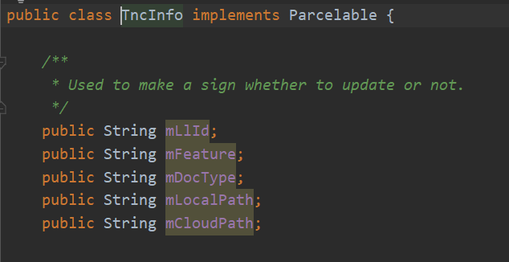

* 1. public void setTncAccepted(String featueId, String llid, String openId);

Set user accept status, take effect immediately.

* 1. public boolean isTncAccept(String feature, String openId);

Get user accept status.

* 1. public void uploadFeedbackContent(String voiceText, String feedbackId, Callback<T> callback);

Specified interface for customer feedback feature to upload user feedback content.

* 1. public void setTncValidTime(String feature, int days, String openId);

Set user selected accept time with specified time. Parameter is feature name and openId(userId) and can’t be null, time counts in day, must be more than 0.

* 1. public boolean withdrawTncAccept(String feature, String llid, String openId);

Withdraw user accept status, return true when successfully withdraw, if user never accepts the agreement, it will return false. Take effect immediately.

* 1. public int getTncValidTime(String feature, String openId);

Get remaining time since user set valid time. Return days in count.

* 1. void onTncChanged(TncInfo tncInfo);

when tnc info updates, use this callback to listen the event, what to notice is that different feature should judge if this tncInfo belongs to this feature.